COUCHBASE Capella Workshop

**Lab Handbook**

Lab 2: Couchbase FTS

# Lab Description

In this section we will explore Couchbase Full Text Search (FTS) on Couchbase Capella.

We will perform the following steps:

1. Access the Full Text Search (FTS) Workbench
2. Create a Full Text Search (FTS) index using the Couchbase Web Console
3. Run an FTS query using the Couchbase Web Console

# 

# Signing In

Go to [cloud.couchbase.com](https://cloud.couchbase.com/), and sign in with your account credentials

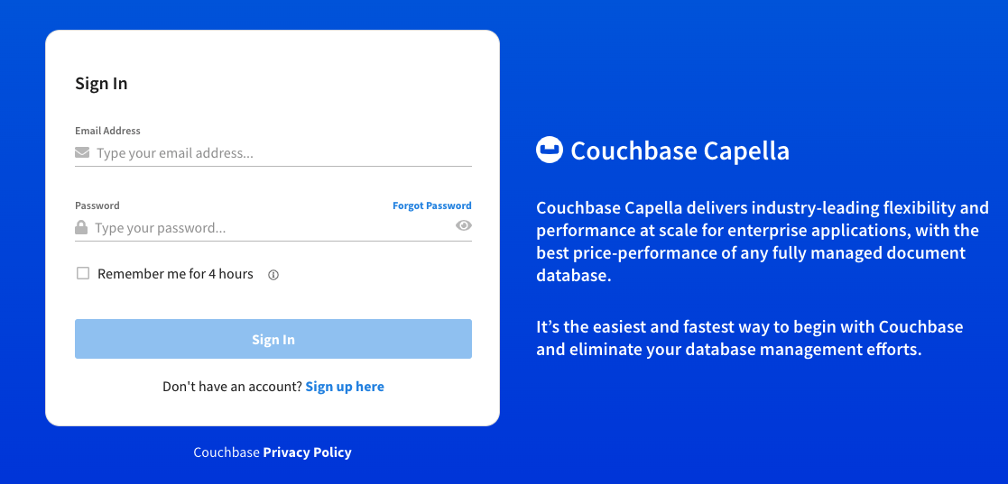

## 

## Step 1: Access the Full Text Search Workbench

Access the Full Text Search Workbench in the Couchbase Capella Cluster by selecting *Full Text Search* from the tools dropdown

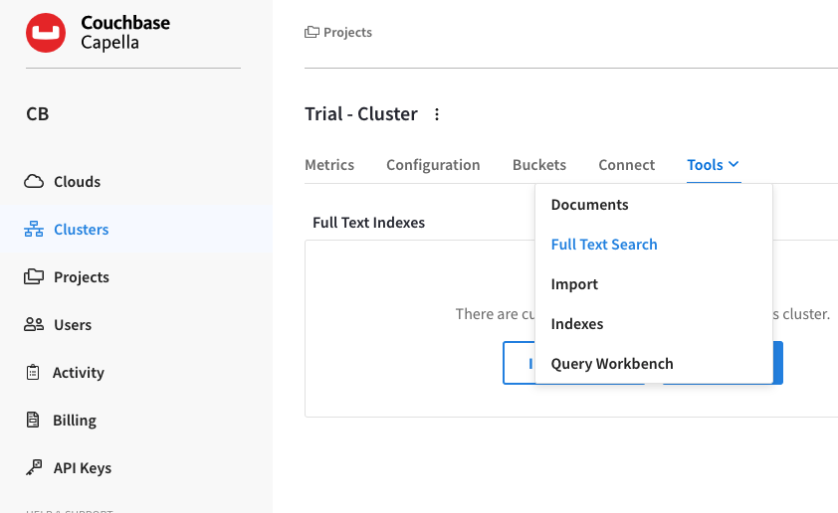

**The Full Text Search screen now appears, as follows:**

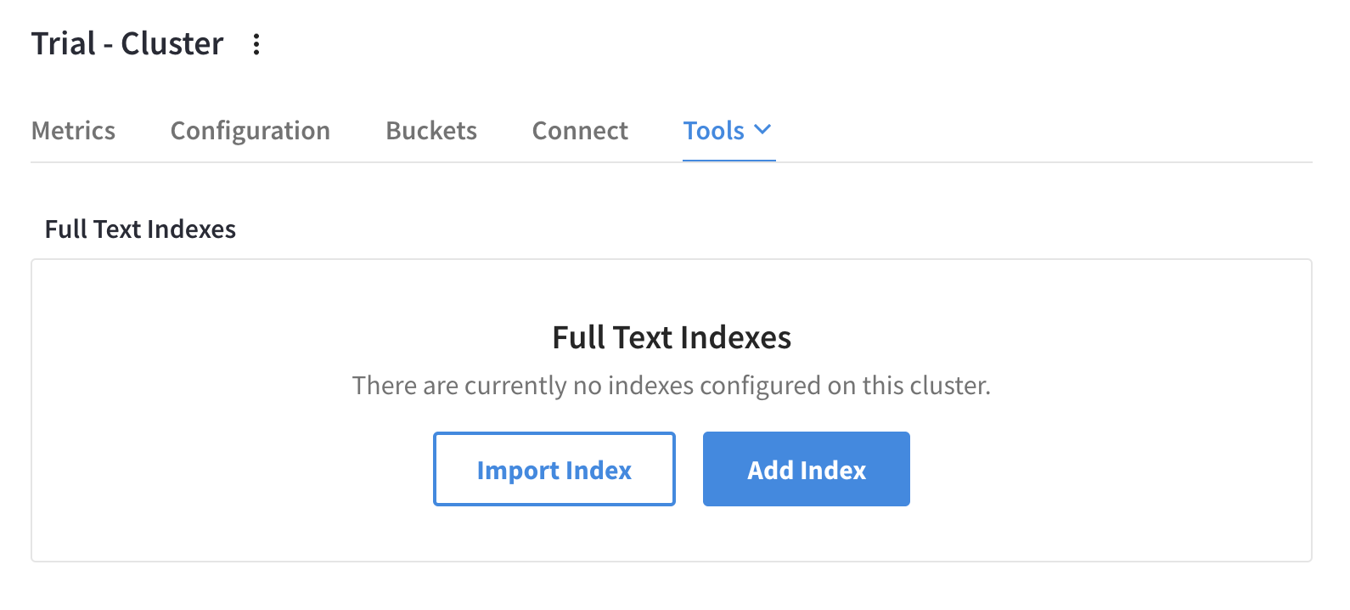

# 

## Step 2: Create a full text search index

1. Click on the **Add Index** button at the top right of the console.

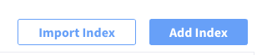

1. In the **Name** field, enter **hotels_<USER_NAME>** as the name of the index.
2. Click on the dropdown **Bucket** and choose **travel-sample** bucket and click “*Continue to configuration*”

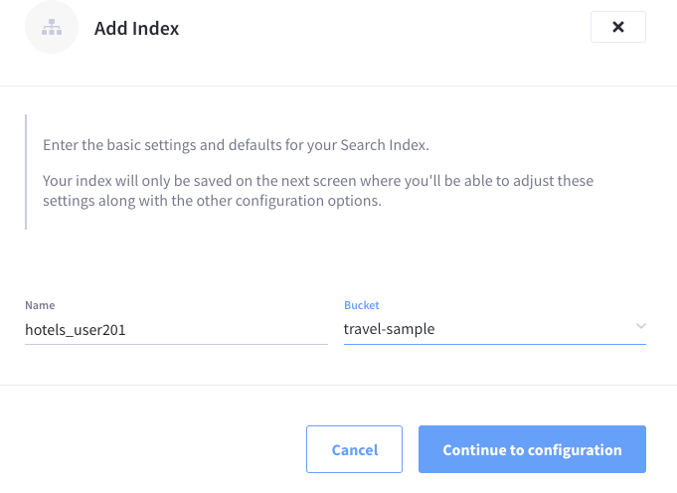

1. Make sure “JSON Type Field” under **Type Identifier** is set to “**type**”

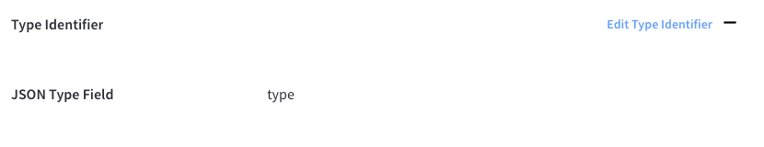

1. Under **Type Mappings**, click on **Add Mapping.** Enter **“hotel”** in the **Name field,** choose **inherit** from the **Default Analyzer** dropdown next to it, check the **only index specified fields** option and click on **“Create Mapping”** button.

*A Full Text Index can be defined not only to include (or exclude) documents of a certain type, but also*

*to include (or exclude) specified fields within each of the typed documents.*

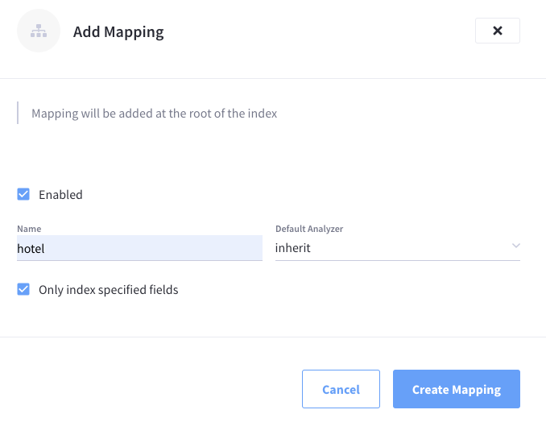

You should see a Type Mapping “hotel” created as follows

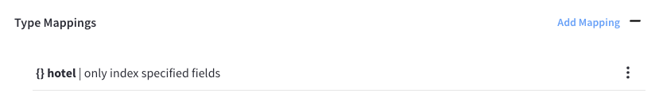

1. Click on three dotson the Type Mappings definition and click on “**Insert Child Field**”

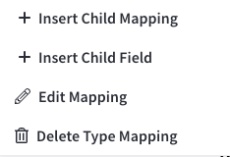

1. In the **Field** box, enter “**description**” and check the **index**, **store**, **include in *_all* field**, **include term vectors, docvalues** checkboxes and click **“Create Child Field”** button

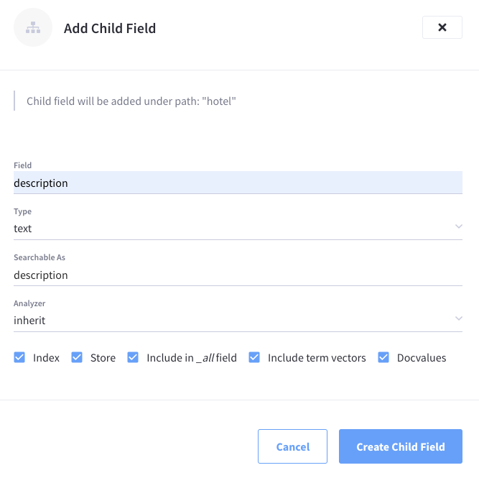

This should create a new child field “**description**” under the Type Mapping “**hotel**” as follows

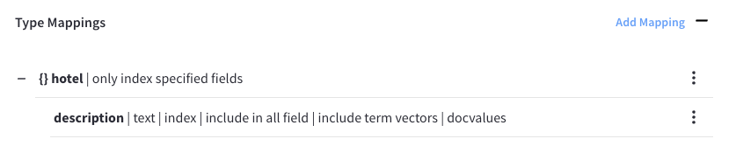

1. Click on three dotson the Type Mappings definition and click on “**Insert Child Mapping**”



1. Enter **“reviews”** in the **Name field,** choose **inherit** from the **Default Analyzer** dropdown next to it, check the **only index specified fields** option and click on **“Create Child Mapping”** button.

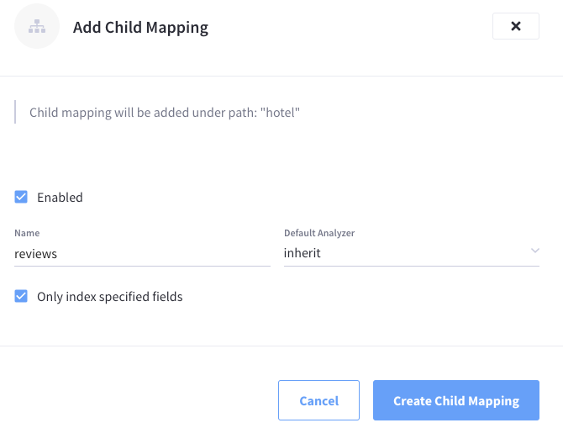

This should create a new child mapping “**reviews**” under the Type Mapping “**hotel**” as follows

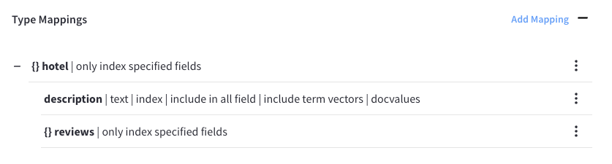

1. On the “**reviews**” Child mapping, Click on three dotson the Type Mappings definition and click on “**Insert Child Mapping**”.

Enter **“ratings”** in the **Name field,** choose **inherit** from the **Default Analyzer** dropdown next to it, **uncheck** the **only index specified fields** option and click on **“Create Child Mapping”** button.

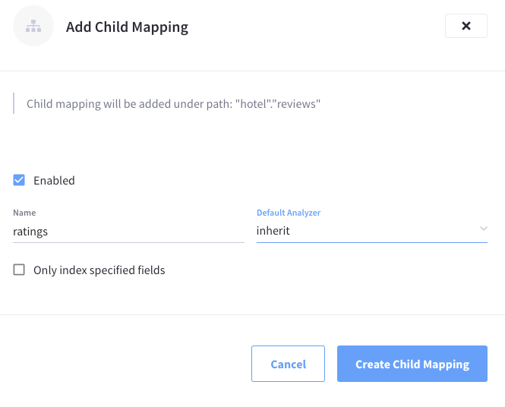

This should create a new child mapping “**ratings**” under the Child Mapping “**reviews**” as follows

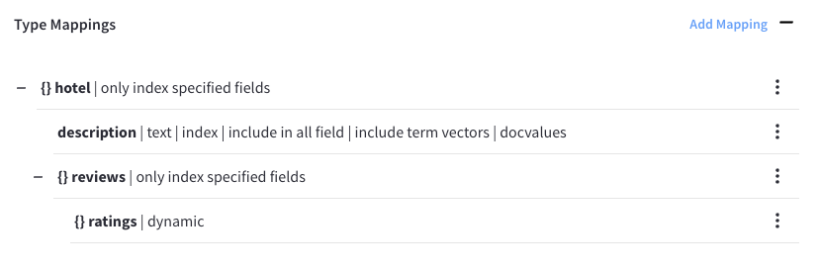

1. Finally, click on the **Create Index** button to create a Full Text Search (FTS) Index.

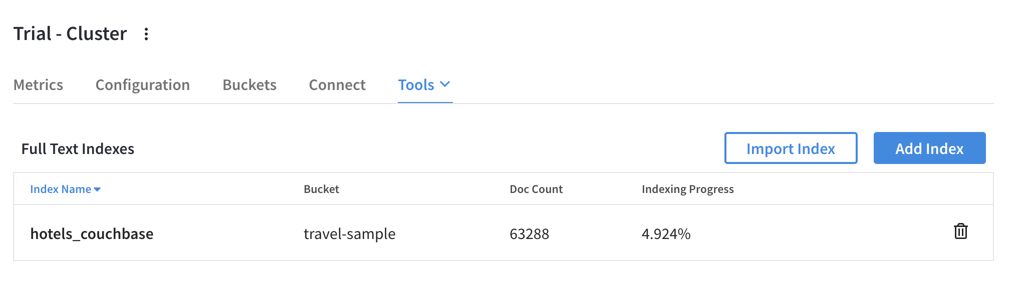

## Step 3: Test the full text search index

Click on the newly created FTS Index



Click on the **Search** button on the right.

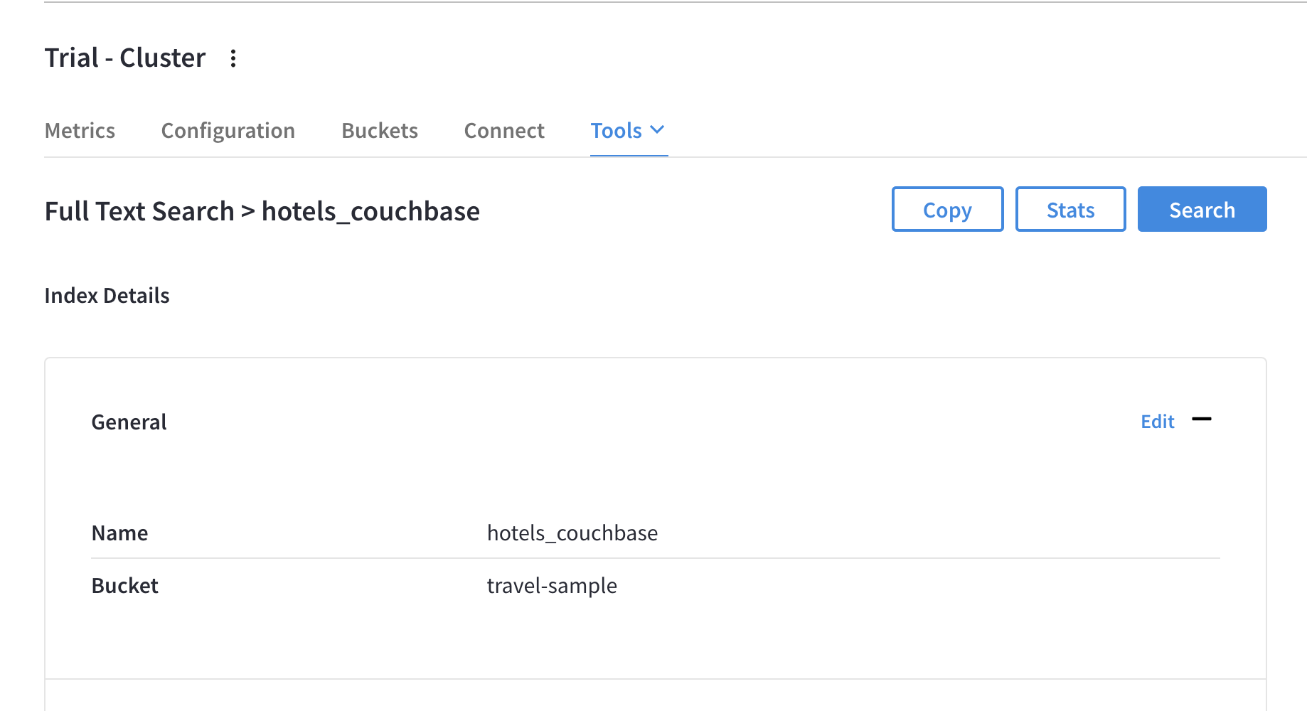

A dialog box will will appear on the right

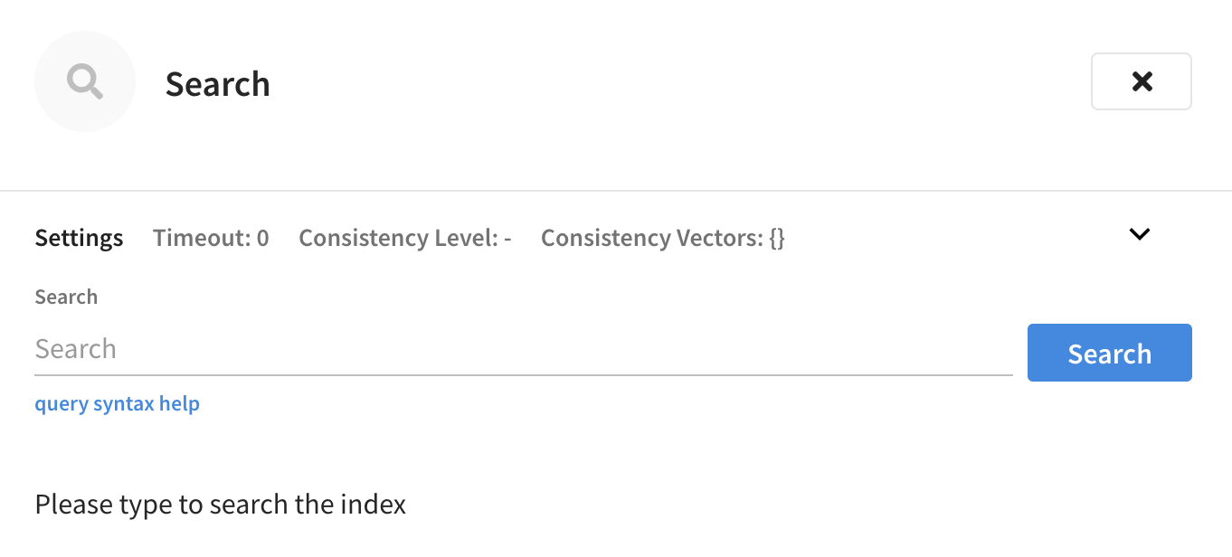

1. Search hotel descriptions for “B&B”

Under the dialog box, enter “**description:B&B**” and click search

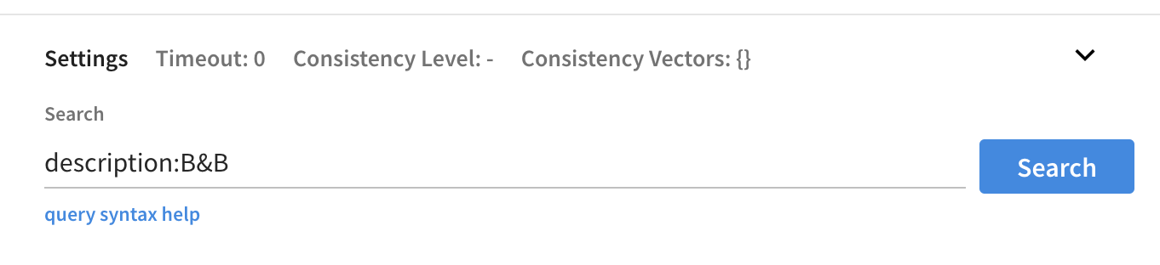

This will search for the term “B&B” on description attribute across all the documents.

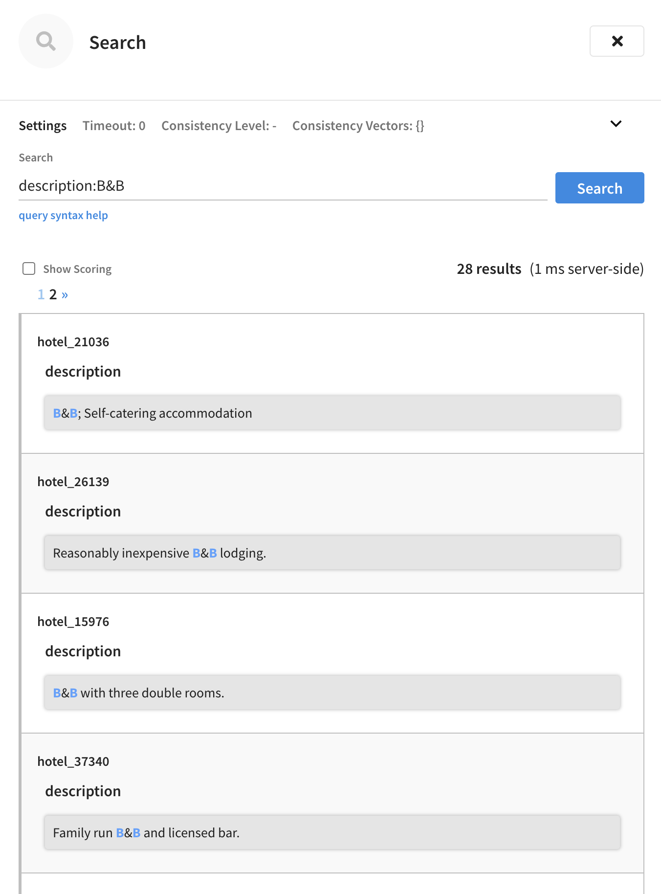

1. Search hotel ratings under the reviews list for cleanliness rating

Under the search dialog box, enter the following

**reviews.ratings.Cleanliness:>4**

**This will return all the hotels with a cleanliness rating of > 4.**

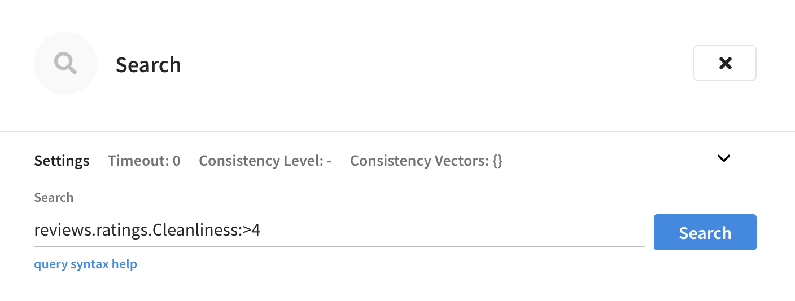

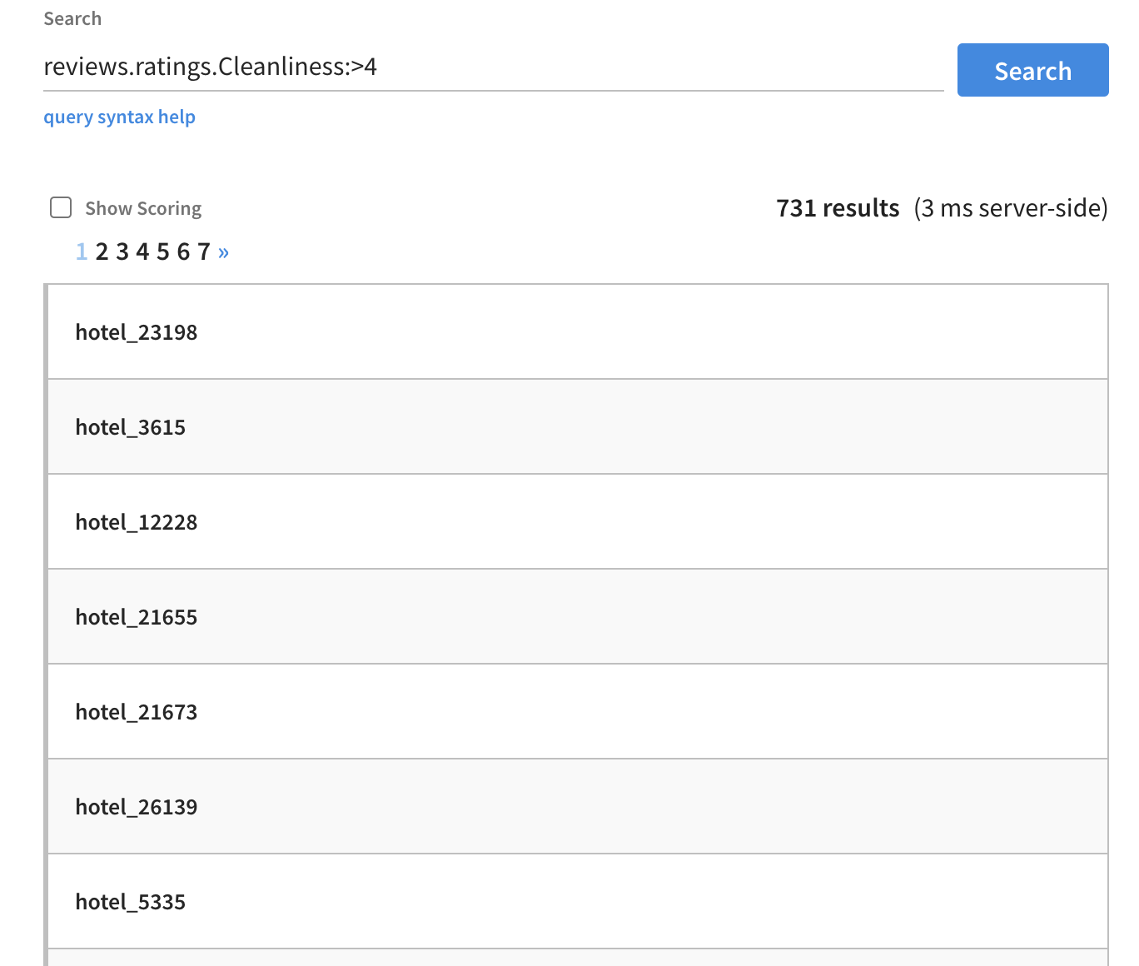

Click on one of the documents to verify the results.



 

 

 

 